1. A close-up of a document

   Description automatically generated
2. A screenshot of a computer

   Description automatically generated
3. 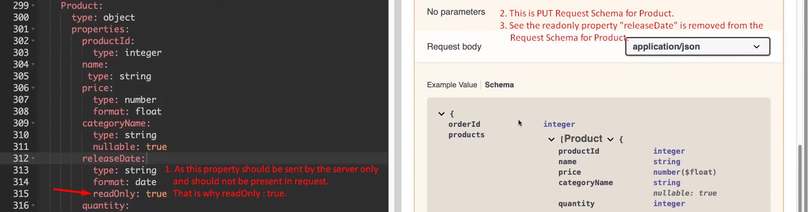  
   A screen shot of a computer

   Description automatically generated